**COTE D’IVOIRE REPORT**

Association Des Femmes Juristes, Cote d’Ivoire (AFJCI) is the Association of Women Lawyers of Cote D'Ivoire, established in 1984. The Certificate of Registration was received on the 14 February 1986, amended in 2006 and 2014. From 1984 to date, nine presidents have succeeded each other while Mrs. Francine AKA-ANGHUI assumed the Office of President in March 2022 and is the incumbent. The members of AFJCI may be women with a Master’s Degree in law or women who operate in the legal field or have had a legal career. Also, male law graduates or members of associations of lawyers may be admitted as associate members.

**Objectives and Missions**

Our mission is:

* To contribute to the promotion of women, family and child's rights, as well as the development of law in general;
* To promote law in rural and semi-urban areas, in particular by raising public awareness;
* To contribute in creating equal justice for all;
* To promote good governance;
* To contribute to improving access to justice for all;
* To work towards the consolidation of peace and security;
* Our Beneficiaries: AFJCl's actions target vulnerable populations: Women, men, young people and children.

Our objectives and mission revolve around the promotion of women, family and child rights with a view to creating equal justice for all towards the consolidation of peace and security.

**Administrative Structure:**

For efficiency in organization and operation, AFJCI is led by a Board of Directors and various Committees.

AFJCI’s has adopted good governance tools such as a charter of good conduct, a policy of gender promotion, non-discrimination, human resources management, recruitment and evaluation of staff, which is included in a procedural manual, a policy of protection against exploitation, sexual abuse and harassment, a policy on anti-corruption, etc.

Its core values include respect for others, non-discrimination, integrity, professionalism and transparency. AFJCI’s own financial resources come from the payment of membership fees, annual contributions, grants, donations, legacies, etc. We receive external financing for the completion of large-scale projects.

**Our Activities**

AFJCI contributes to the development of law in Cote d'Ivoire through various means: publicising legal cases/judgments through awareness raising, training, providing legal and judicial assistance, providing support for legal documentation, design of information, brochures, manuals and legal guides, visiting prisons and correction centers, training courses, animation of radio and TV programmes.

This is done in Abidjan and in the hinterland. We run thirteen legal clinics, eleven fixed legal clinics and two mobile track legal clinics. We have had various legislative advocacies that led to the adoption of laws on matrimonial causes, marriage and tax matters.

**GBV Data in 2022**

Through our legal clinics, AFGCI was able to train more than 5000 people, sensitize nearly 50,000 people on sexual assault, physical aggression, early and forced marriages, denial of resources and opportunities, psychological and emotional abuse, all GBV.

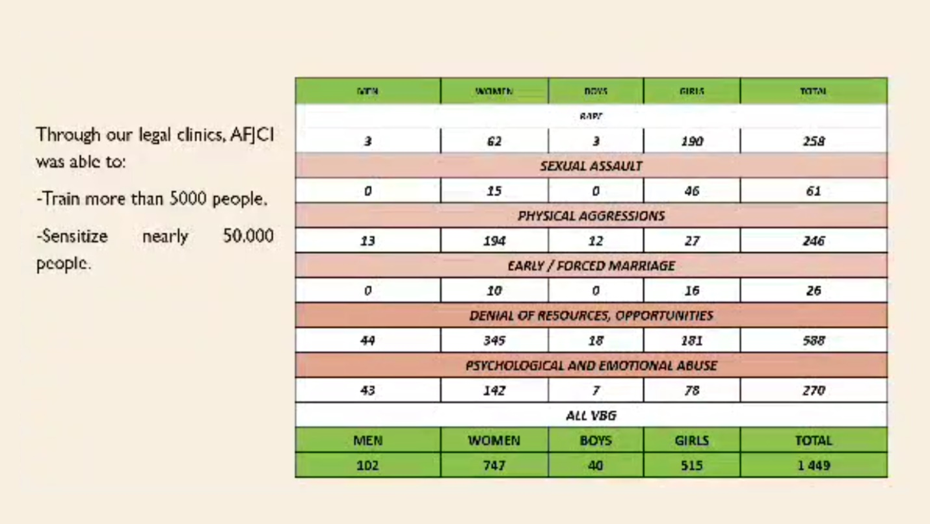

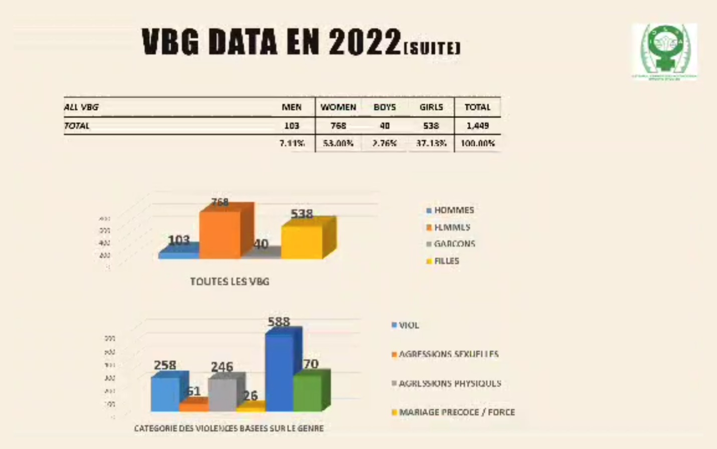

These are the statistics on actions outside GBV, including case of referrals, issuing supplementary judgments for a person at risk of statelessness, issuing documentation, confirming of nationality, request for miscellaneous information, rural land issues and succession.

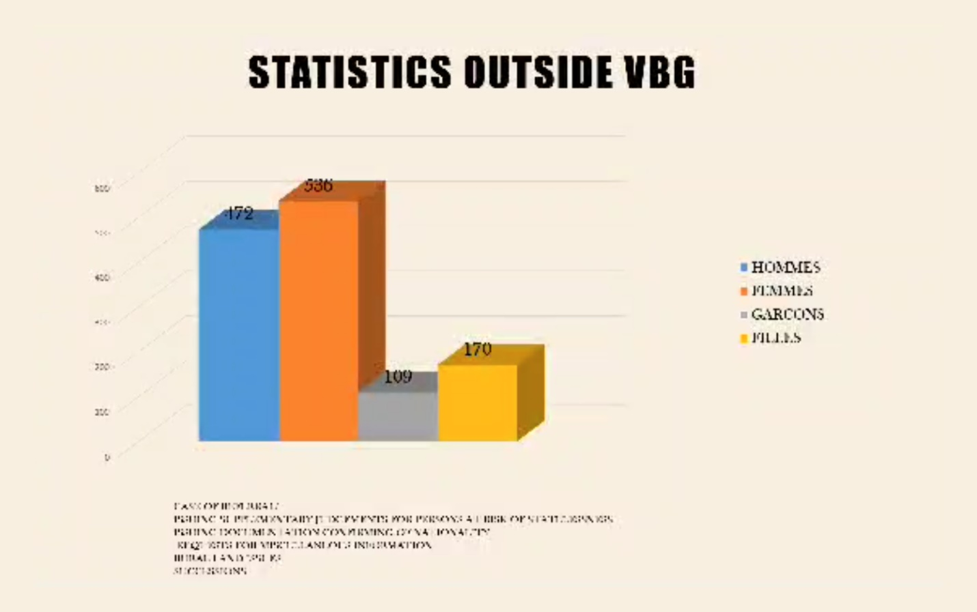

The status report of the implementation of the Maputo protocol in Cote d'Ivoire.

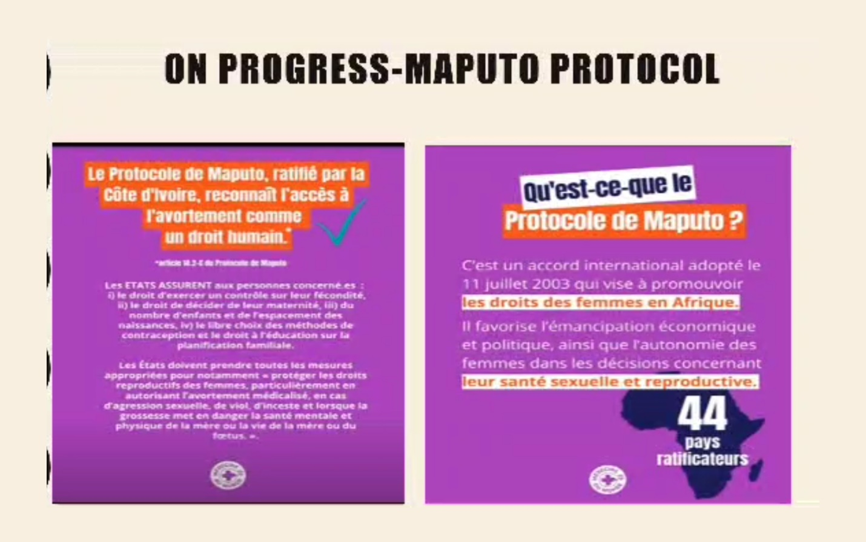

On the progress side, the Maputo protocol was ratified by Cote 2022. The adoption of the treaty was a very important event in the fight for women’s rights in terms of recognition and promotion of their rights. Cote D'Ivoire stepped in with a vast reform of legal test of laws right after the ratification of the said protocol.

First, since 2019, major changes have been adopted in the law on marriage, filiation and inheritance, in order to strengthen equality between men and women and to balance relations between spouses and with regards to children.

Change is also in the area of violence against women, peace and security, socio-economic empowerment, food security and nutrition, political participation of women, the law on the 30% quota for women.

In addition, socio-cultural patterns and models of behaviour for men and women have been modified by pre-public education and the implementation of information.

Thank you!

**Francine Aka Anghui**

**President, Association of Women Lawyers of Cote D’Ivoire**

**(October, 2024)**