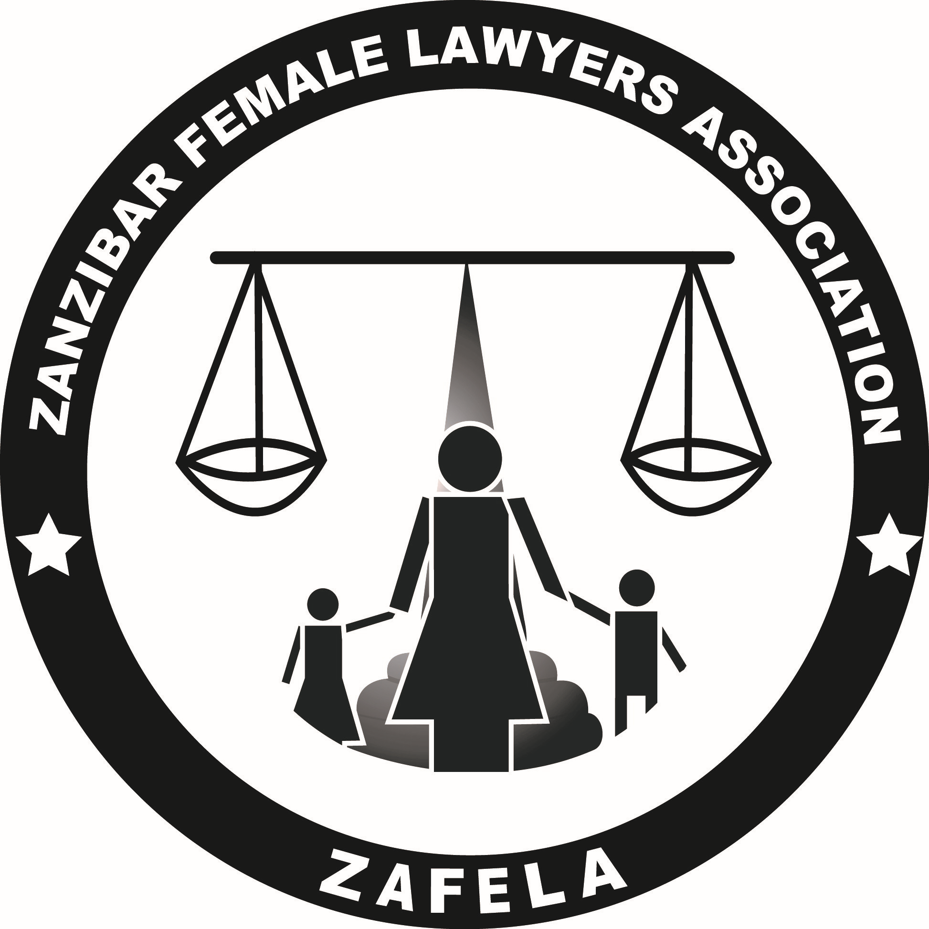

**Zanzibar female lawyers association (zafela)**

**ZAFELA IMPLIMENTATION REPORT**

1. **Background information**
2. **History and overview**

Zanzibar Female Lawyers Association (ZAFELA) was founded in 2003 and officially registered in 2005 as an Association under The Societies Act (No. 6 of 1995). It worked with that status until 2022 when the BPRA Act No. 12 of 2022 was introduced with the effect of directing all institutions with Non-Government Organization (NGO) activities to be registered under the BPRA. ZAFELA went through the compliance process as enshrined in the Act No. 12 of 2022 and re-registered with Registration No. Z000018430.

The aims and objectives of the organisation are to advocate for gender equality, promotion of human dignity and gender justice through policy, legal and institutional reforms, community action and media engagement.

1. **Geographical Coverage**

From 2003, ZAFELA’s physical presence has remained at its headquarters in (UNGUJA) although it was serving the whole of Zanzibar Unguja and Pemba. However recently, ZAFELA managed to open sub office at Pemba.

1. **Strategic objectives**
2. Enhanced promotion of legal reforms and enforcement of implementation of 60 % of Law and Regulations Governing women and Children’s rights in Zanzibar.
3. Enhanced knowledge of Civil Rights and Awareness of Legislative Procedures by 60% of women and children in Zanzibar.
4. Enhanced provision of legal and human rights issues through effective legal aid service provision by various institutions by 65% in 2028.
5. To strengthen the dissemination of policy materials on laws, regulation and guidelines governing women and children’s rights by 60%in 2028.

1. **Contribution of ZAFELA to the Sustainable Development Goals**

The following values govern our work, as we strive to achieve ZAFELA’s mission:

**GOAL 1: No Poverty: End Poverty in all its forms everywhere.**

ZAFELA’s programs contribute to this SDG by ensuring women have equal rights to economic resources, ownership and control over land, inheritance, natural resources and contribute to improvements of livelihood. Access to decent, safe and affordable housing program equally responds to initiatives to eliminate poverty.

**GOAL 5: Gender Equality: achieve gender equality and empower all women and girls;**

Substantive part of ZAFELA’s activities contribute to this SGD through advocating for women’s rights to access, own and use land, intervention to ensure women’s active and effective participation in leadership at all levels of decision-making as well as ensuring access to sexual and reproductive health rights for women of reproductive age.

ZAFELA’s day to day work on legal aid provision contributes to the realization of this goal through its contribution to reduction and elimination of all forms of discrimination against women and young children by ensuring access to justice, raising awareness on women and children’s legal rights, and to ensure that discriminatory and harmful practices are eliminated.

**GOAL 16: Peace, Justice and Strong institutions**

ZAFELA’s contribution to this goal is reflected through a program contributing to strengthened CSOs for enhanced democratic and inclusive electoral processes and more accountable leadership in Zanzibar and Tanzania during and after the 2020 general elections, by which promotion of accountable leadership and peaceful environment in post-electoral Tanzania has been a priority.

1. **Advanced gender equity through programmes that promote accountability, progressive laws, transparency, and access to justice**
2. **Sustainable Access to Justice and Legal Aid**

ZAFELA continues to provide legal aid services and counselling at its main office in Unguja. For the year 2022 a total number of 386 new clients visited ZAFELA’s office. Successfully finalized cases, including maintenances cases, custody, inheritance, divorce and winning them has proven to be advantageous in providing financial Support, to entitled individuals particularly children, which can be utilized to meet their fundamental requirements such as food, medical care and education.

1. **Self-representation training**

ZAFELA through its legal aid clinics conducted training on how clients can represent themselves before courts of law/tribunals. The purpose of these trainings is to impart knowledge and skills to legal aid clients on how to represent and defend their cases before courts of law and tribunals. A total of **150** clients were trained and their capacity to represent themselves in the courts of law and tribunals were increased.

1. **Reconciliation**

As an experienced legal aid provider, ZAFELA normally assesses the disputes reported by clients in its legal aid clinics and facilitates reconciliations through separate sessions with both parties to the disputes and other necessary individuals before embarking on court processes. This strategy is voluntary and has facilitated harmonious resolutions to several disputes. This also saves resources and public time which could be wasted if court processes are opted for. In 2022 a total of 362 civil cases filed for reconciliation and 300 cases were successfully settled out of court while 62 reconciliations failed and further legal processes were opted. While a number of 24 criminal cases (including rape, defilement, Sodomy and dissent assault) were scheduled for follow up at the Police stations, DPP office and Courts.

1. **Pro-Bono Sevince**

ZAFELA members who subscribe to ZAFELA’s objectives have been offering legal aid services through a Pro-Bono Scheme established since 2003. In the year 2022, a total number of cases were represented in various judicial forums through ZAFELA Pro-Bono Scheme in Zanzibar.

1. **Mobile legal aid**

In ensuring that legal aid services reach a wide range of community, ZAFELA conducted several mobile legal aid sessions and reached more than 3000 community members in the Unguja and Pemba. These sessions were held along celebrations of law week and International Women’s Day, and monthly community meetings.

1. **Legal education**

ZAFELA in collaboration with different stakeholders including the judiciary, Zanzibar Law Society (ZLS), social welfare offices, police, gender and children’s desks and government officials through Legal Aid Department in the commemoration of Legal aid week under the theme “Legal Aid for a Just and Inclusive Society” from 1-8 March 2022 Unguja and Pemba. ZAFELA provided legal education in probate, matrimonial, civil, GBV and land issues and more than 1000 people were reached.

1. **Paralegal services**

In the quest to ensure access to justice, all paralegal services which ensure access to legal aid services in nearby communities remained imperative. In the year 2022, ZAFELA continued to partner with paralegal units by offering capacity building opportunities to paralegals and strengthening working relationships and referral mechanisms.

1. **Strengthening Women’s Participation and Representation in decision- making process in Tanzania**
2. **Women’s Access to justice in administrative Kadhis Court Act no. of 2018**

Zanzibar has adopted a very progressive legal framework on women’s access to justice through Kadhis Court, whereby women are legally entitled to access, own, and use matrimonial properties directly; however, a gap between the narration of the law and practice has existed since then. Thus, ZAFELA’s work on women’s rights has been to address the gap through capacity building for women and decision makers to remedy the knowledge gap.

Further, ZAFELA innovatively takes advantage of the opportunities in the legal framework to translate and extend legal avenues ensuring women’s access to their matrimonial properties and initiating public dialogues aiming to diminish harmful practices sidelining women from the full enjoyment of their property rights. Realising all the above narrations, projects on Legal Empowerment & Access to Justice Programme, Strengthening Women’s Participation in Leadership and Empowering Community to End GBV in Zanzibar were implemented in 2022.

1. **Psychosocial support for GBV victim program**

Psychosocial support program is an essential building block to achieving gender equality, with special focus on the reduction of the trauma for gender-based violence victims. It is from that context that ZAFELA continues to advocate for advancing psychosocial support for women and children especial SGBV victims. In so doing, several interventions were implemented including training for Social workers on provision of psychosocial support which aimed at increasing awareness and service provision.

1. **Gender Equality and GBV**

Gender-based violence (GBV) is a serious violation of human rights and a life-threatening health and protection issue in our society. It is estimated that one in three women will experience sexual or physical violence in their lifetime. It is from that context that, ZAFELA with other partners including Zanzibar Women with Disability (JUWAUZA), Tumaini jipya from Pemba (TUJIPE), Zanzibar Women with disability organization and Tanzania Media Women Zanzibar branch (TAMWA) through fighting against GBV program for women, children and people with disability continues to implement various interventions to combat GBV in Unguja and Pemba with advocacy activities at national level. This includes ensuring timely provision of legal aid services to victims of GBV, media campaign reporting to GBV victims, building capacity of law enforcers, especially Police Gender and Children Desks and NPA/VAWC Committees in responding to GBV incidents, building community awareness on GBV and reporting mechanisms.

1. **Women and Youth Political Representation and Leadership**

Low representation of women and young people in leadership and decision-making structures at different levels has continued to be a barrier against efforts challenging the structures and frameworks nursing or perpetrating GBV. This underrepresentation demonstrates the tale of GBV existence in our communities. Various initiatives including raising community awareness through community brigades and male champions on inclusion of women and youth, enactment of gender sensitive and youth focused bylaws on village governance, mentorship programmes on leadership, review of the existing laws on the women position in decision-making have been conducted. All these continued to challenge the status quo and changing negative societal attitudes against women and youth.

Recently, ZAFELA in collaboration with TAMWA through Strengthten Women in Leadership program (SWIL) which aim to increase the participation of women in democratic processes from local and national level through training session to the aspirant’s young women on the importance of gender mainstreaming women agenda in Parliament, about 138 journalist trained on reporting women stories. The engagement expected to increase representation of women at national level and Parliament as well as enhancing a more enabling national policy and legislative environment for gender equality.

1. **Stakeholders Engagement, Partnership, Collaboration and Networking**

Stakeholder engagement is the process by which an organisation involves people who may be affected by the decisions it makes or can influence the implementation of its decisions. ZAFELA engaged with different stakeholders by attending various forums such as ‘Validation Meeting of the Child Justice Forum – the 2nd five-year strategy for progressive reform’ hosted by Ministry of Constitutional and Legal Affairs in Dodoma. ZAFELA also took part on ‘Stakeholders’ forum on the Universal Periodic review’ hosted by the Commission for Human Rights and Good Governance (CHRAGG) in Dodoma.

ZAFELA also conducted Shehia level meetings (local government) with various community stakeholders to make a general proposal on gender sensitive bylaws and managed to identify gaps.

On the other hand, ZAFELA in collaboration with the United Nation High Commission for Human Rights organised a two-day workshop for lawyers and Human Rights CSOs in Zanzibar to support judicial institutions in Tanzania. The workshop was based on straightening women’s access to Justice in Zanzibar.

1. **Governance and Rule of Law**

Good governance and the rule of law are essential preconditions for the fulfilment of the Sustainable Development Goals (SDGs) as they are prerequisites to peace and stability without which societies cannot function, let alone flourish. The commitment to good governance and promotion of the rule of law enhanced ZAFELA to facilitate enactment of gender sensitive and youth focused by-laws to strengthen women and young people’s voices and participation in governance. From that context, ZAFELA supported reviewing of the number of laws and policies including Kadhi’s court Act, Media Laws, Political Party law. The purpose of facilitating the reviewing was to increase women and young people’s voices and participation in governance of community affairs from the local to national level. The reviewed laws address structural barriers that limit effective participation of women and youth in key decision-making structures. The reviewed laws also touch various sectors including land, water, natural resources, pastoralism, and agriculture and try to bridge the gap in terms of what is provided within national laws and policies with practice on the ground which hinder democratic rights.

1. **Research and Evidence Based Advocacy**

To facilitate research and evidence-based advocacy, ZAFELA engaged a consultant to review Zanzibar policies and laws to highlight the discriminatory nature of the women’s rights to participate in leadership and decision-making positions with the view of generating evidence to be used as an advocacy tool in engagement with relevant authorities. A report was used to engage different stakeholders including Law Reform Commission, MOCLA and Parliament in the quest to challenge discriminatory rules in leadership laws. The Zanzibar Women Parliamentary Wing has registered its commitment to work on the identified challenges. To establish the starting point of the project and assess the situation on the ground, a baseline survey was conducted to ascertain the number of women in leadership position and democratic process, before implementation of the Strengthten Women in Leadership program (SWIL) and Together for Peace Activity. The findings of the survey were used to establish targets in different areas which the activity is addressing. The survey was conducted in collaboration with TAMWA and KAS. The findings indicate several gaps whereby several councils/tribunals and committees do not have requisite number of women and in certain places they are made of individuals with other conflicting roles. ZAFELA has been engaging LGAs to address such anomalies and advocate for inclusion of younger people in the said structures

1. **Strengthened ZAFELA Brand and Visibility**

ZAFELA is an organisation with wide membership rights and obligations articulated in the constitution. The existing members have technical capacities to support women and communities to access justice through diverse approaches. TAWLA continues to implement its programme with the objective to retain, utilise and increase members’ participation and ownership of the organisation for effective delivery of TAWLA mission

1. **ZAFELA rebranding**

Membership Growth, Engagement and Networking Membership Growth, Engagement and Networking

Member engagement in ZAFELA planned activities

Members handling ZAFELA clients cases

1. **Media Engagement and Communication**

ZAFELA in promoting its branding and communication use both social media, broadcasting and printing media to explore the number of its interventions. ZAFELA use media as means of communication with the community and the way of reporting what has been done or to be done in the future. In doing so ZAFELA is creating the enabling environment for journalists to make sure they report the accuracy and timely information regarding women in leadership, economic empowerment and GBV incidences.

However, ZAFELA with the collaboration with other partners builds capacity of journalists through awareness trainings and workshops. Also, ZAFELA motivates journalists via media awards and recognitions for those who featured good reports on Gender and good governance during the 16 days of activisms.

1. **Achievements**

* ZAFELA has successfully facilitated the enactment of the gender sensitive and the division of matrimonial assets after divorce law which is known as Kadhis Court Act.
* Increased collaboration with other women’s rights organizations and other human rights organizations.
* ZAFELA has magnanimously continued to provide legal assistance to vulnerable women and children.

**7. Challenges**

* With the decline of funding to CSO’s, the organization has continued to operate with minimal resources to cater for operations to support execution of its mandate. However, different efforts including forging partnership with other organizations have been put in place for sustainability of the organization and its activities.
* There are increased demands for legal representation in the organization’s legal aid and clinic. Few registered advocates working with the organization as employee and established Pro-Bono Scheme clients cannot meet the present demand. The organization has continued to reach out to its members and law firms to seek a hand of support in the provision of legal aid, especially through court representation.

1. **Conclusion**

This report has highlighted the engagement made by ZAFELA in the year 2022 in line with her Strategic Plan. ZAFELA appreciates the support from the Government, Development partners, Private organizations, as well as ZAFELA members, The Board Members, the Board of Directors, staff, and all beneficiaries including the public who all together, made possible the implementation of ZAFELA objectives.